Press Release September 2012

Exposure Meters with New Design

GOSSEN Foto- und Lichtmesstechnik GmbH has updated its products and is presenting them in a new exposure meter catalog.
Innovations showcased in the catalog include the revamped, compact DIGISIX 2 with a weight of just 40 g, as well as the DIGIFLASH 2 as an ideal enhancement for minimalistic, but nevertheless demanding photographic equipment. They expand the measuring functions of manually adjustable cameras to include incident light measurement, by means of which better exposure can be achieved for unusual subject contrast. Integrated contrast measurement also indicates whether or not subject contrast, i.e. the difference between the brightest and darkest part of the subject, can be managed by the sensor or the film. With its additional flash function, the DIGIFLASH 2 is the smallest flash exposure meter in its class.

The DIGIPRO F2, a diverse standard tool for photographers and filmmakers, features functionality which has been expanded to include the display of exposure values in 1/2 or 1/3 stop increments. The included technology and features are high quality, and operation is clear-cut and easy to understand. The universal DIGIPRO F2 is laid out for use in the studio, as well as outdoors. It makes quick work of incident and reflected light measurements for flash and ambient light, displays mixed lighting conditions as well as required multiple flashes, and performs contrast measurements. It masters all common lighting situations for analog and digital photography, as well as filmmaking, with outstanding precision and time-tested quality.
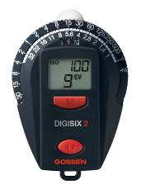
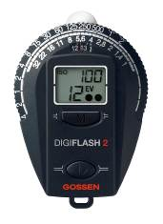
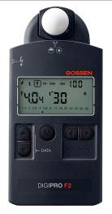
Images: Product Photos DIGISIX 2,
DIGIFLASH 2,
DIGIPRO F2

Further information:

GOSSEN Foto- und Lichtmesstechnik GmbH, Lina-Ammon-Str. 22, D-90471 Nuremberg
Klaus-Peter Richter, phone: +49-911-8602-180, e-mail: klaus-peter.richter@gossen-photo.de

