Press Release August 2012

MAVOLUX 5032 B/C USB with optimized Photometer-probe

GOSSEN Foto- und Lichtmesstechnik GmbH has further improved and enhanced their precision, DIN-classified illuminance meters MAVOLUX 5032 B USB and MAVOLUX 5032 C USB .

The Diffuser used on the Photometer probe has been reduced in size and recessed, improving the measuring efficiency by lowering the levels of extraneous light entering the meter. DIN 5032 defines classes B and C to measure at an angle in the range between -85°…0…+85°. It is not only that the small deviation of the cosine adaptation could be minimized now but the complete range of the measuring angle of the Mavolux meters could be widened to 90°. As a result measurements from the Meters are guaranteed to consistently exceed the DIN standard.

Similarly the optional Luminance attachment has been updated, and couples together with the Mavolux 5032, allowing it to be used as an unclassified luminance Meter.

For purposes of documented evidence, for which meters must be recalibrated at regular intervals, GOSSEN Meters can be issued with either Factory Calibration certificates for luminance and illuminance, or DAkkS Certificates for illuminance, for which the GOSSEN Light Laboratory has been internationally accredited since 12 July 2012.

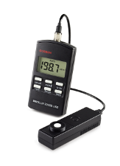
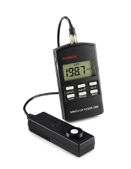
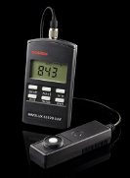
Images:

For further information please contact:
GOSSEN Foto- und Lichtmesstechnik GmbH, Lina-Ammon-Str. 22, D-90471 Nürnberg
Klaus-Peter Richter, Telefon: +49 911 8602 180, E-mail: klaus-peter.richter@gossen-photo.de

