Press Release April 2014

MAVOLUX 5032 C BASE

GOSSEN Foto- und Lichtmesstechnik GmbH has enhanced its family of high precision and classified illuminance meters by the new MAVOLUX 5032C BASE. The inexpensive product is classified according class C in accordance with DIN 5032-7 and appendix B of IEC 13032-1. The high-end V(λ) matching and cosine correction guarantees the reliably measure for illuminance of daylight and artificial sources of light including LED.
The MAVOLUX 5032C BASE is used primarily as an industrial measuring instrument for planning, installing, inspecting and monitoring lighting systems, as well as for the assurance of compliance with specified lighting conditions. Its four measuring ranges with automatic or manual range selection cover a broad span from 0.1 to 199,900 lx with an accuracy level of ± 3% ± 1 digit. V(λ) matching deviation, which amounts to f1‘ < 7.5%, is considerably better than the permissible error limit for class C specified in the standards.

At GOSSEN, great emphasis is placed upon reliability of measuring results by means of calibration. As an option, the accredited GOSSEN Light Lab can issue a factory or a DAkkS calibration certificate for measuring equipment monitoring in accordance with DIN EN ISO 9001:2008. Depending on how the meter is used, we recommend a calibration interval of 12 to 24 months. Optionally there is valuable plastic carrying case available.

Images:
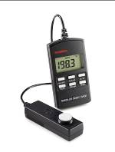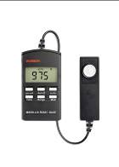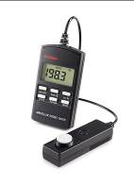

For further information please contact:

GOSSEN Foto- und Lichtmesstechnik GmbH, Lina-Ammon-Str. 22, D-90471 Nürnberg
Klaus-Peter Richter, Telefon: +49 911 8602 180, E-mail: klaus-peter.richter@gossen-photo.de

