Press Release March 2017

World Premiere – Spectrometer with Integrated TM-30-15

GOSSEN Foto- und Lichtmesstechnik GmbH has expanded its MAVOSPEC BASE spectrometer to included measurement of the new color rendering index in accordance with TM-30-15. For the first time, the new method defined by the North American Illuminating Engineering Society (IES) for evaluating the color rendering of light sources is now being offered in a compact spectrometer. As opposed to solutions with external programs, the MAVOSPEC BASE provides excellent operating convenience for on-site measurements.

The new TM-30-15 color rendering standard makes use of 99 reference colors which are distributed over the entire color space. As a result, it makes use of significantly more colors and hues for the calculation of fidelity index Rf, which describes the same relationship as color rendering index Ra. Gamut index Rg provides information concerning color saturation and color shift, and is similar to gamut area index GAI used previously for the examination of color rendering.

Color rendering index Ra (average of R1 to R8 values) and individual indices R1 through R15 in accordance with CIE 13.3 have been supplemented with color rendering index Re (average of R1 to R15 values) and gamut area index GAI. The latter is used primarily for the evaluation of exhibition and museum lighting and is a measure of the vividness of the color representation.

Illuminance Ev (lx) evaluated by means of relative luminosity curve V(ʎ) has been supplemented with unweighted irradiance Ee (W/m²) within a range of 380 to 780 nm. The quotient of values Ev/Ee yields luminous efficacy of radiation LER (lm/W) and indicates how much of the generated radiation of a light sourced is perceived as light by the human eye.

Additional measured quantities including correlated color temperature, Duv, color coordinates in accordance with various CIE standards, color purity, flicker (index, %, f), spectral power distribution, peak wavelength and dominant wavelength are determined from the measured spectrum and displayed at the highly legible color display such that they can be understood by experts as well as laypersons. User-friendly, intuitive operation is made possible by the ring controller and just a few keys.

A diverse range of applications makes the MAVOSPEC BASE a reliable partner to the lighting specialist where selection, coordination, inspection, verification, comparison and evaluation of the light and color quality of various light sources from different manufacturers are concerned.

Measured values can be saved to the 4 GB micro SD memory card integrated into the battery compartment either automatically or manually. Excel can access the CSV files directly via the USB port and the user can process them in his own reports. GOSSEN provides an Excel file free of charge with various reports for documenting measured values, which can be modified as desired by the user. No separate software is required. The open interface protocol and continuous power supply via USB also permit integration into customer-specific test systems.

Appropriately for modern light sources, the MAVOSPEC BASE is sustainably equipped with a replaceable, rechargeable lithium-ion battery and a software update function via the USB port. New firmware version 1.10 can be downloaded from GOSSEN’s website free of charge and installed to the user’s existing devices. And thus GOSSEN is fulfilling its commitment to remain open to future function expansions and changes to standards, so that the user’s investment in the cost-effective meter is being rewarded already with a long service-life. Outstanding product quality is assured by the “Made in Germany” seal and the accredited GOSSEN Light Lab.

Further information:

GOSSEN Foto- und Lichtmesstechnik GmbH, Lina-Ammon-Str. 22, D-90471 Nuremberg, Germany
Klaus-Peter Richter, phone: +49-911-8602-180, e-mail: klaus-peter.richter@gossen-photo.de
Images:
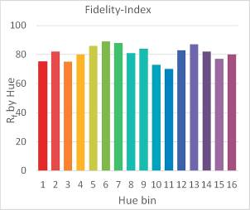
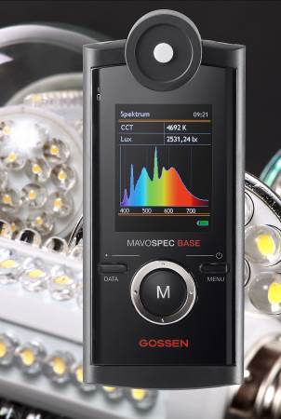
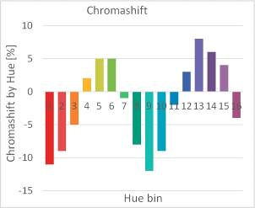
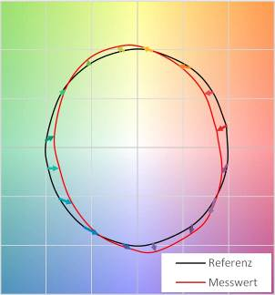
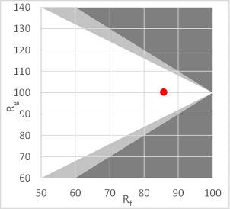
Graphic 1: Fidelity Index by Color
Graphic 2: Color Shift by Color
Graphic 3: Gamut Index Relative to Fidelity Index
Graphic 4: Color Vector Graphic
Figure 1: MAVOSPEC BASE

